ELEMENTS - SYMBOLS

Definitions
Element: substance that contains atoms that are all the same.
(Elements have atoms with the same number of protons in the nucleus.)

Atomic Number: number of protons in the nucleus.

Mass Number: number of protons and neutrons in the nucleus.

Each element has its own particular number of protons, neutrons and electrons.

These numbers are represented using the following general symbol.

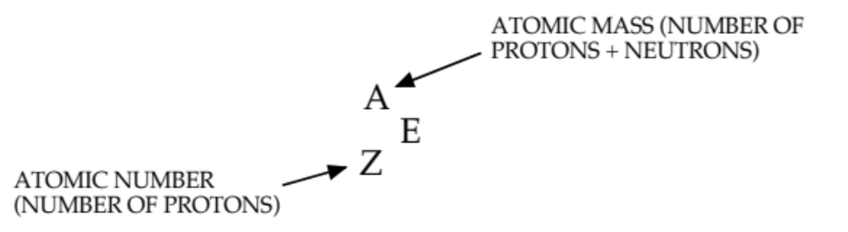

Examples

ELEMENT PROTONS NEUTRONS ELECTRONS
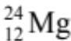 12 12 12

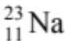 11 12 11

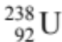 92 146 92

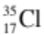

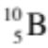
Isotopes
• Defined as different atoms of an element that have the same number of protons but different numbers of neutrons in the nucleus.
e.g. Most oxygen atoms exist as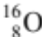.
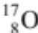 and 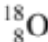 are two isotopes of oxygen.

Carbon has the following isotopes.
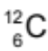 (normal carbon), 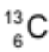 and 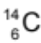 (which is radioactive - called a radioisotope).

Hydrogen has 3 isotopes.
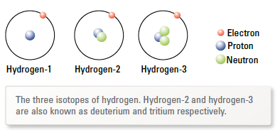
There are 92 naturally occurring elements and 26 man-made ones.
These are arranged by atomic number in the Periodic Table.
The elements can be classified as metals and non-metals.

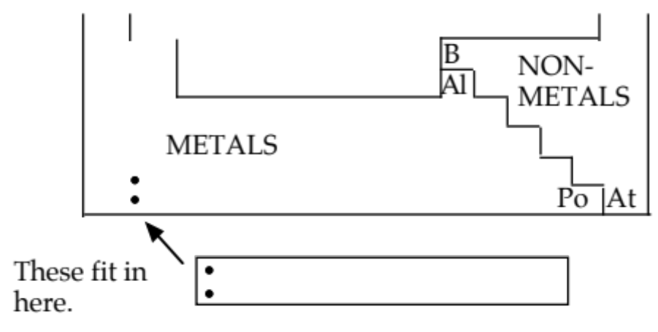

Metals are found on the left hand side of the table, non-metals to the right.
Along the diagonal shown are metalloids or semi-metals that show properties of both metals and non-metals.
The symbols for elements always start with a capital letter, and the second letter (if used) is always lower case.

e.g. Al - aluminium C - carbon

The symbol is based on the English name, though some are based on Latin, Arabic and German names.

NON-ENGLISH ENGLISH

sodium Na hydrogen H
potassium K helium He
iron Fe lithium Li
copper Cu beryllium Be
silver Ag boron B
tungsten W carbon C
gold Au nitrogen N
mercury Hg oxygen O
lead Pb fluorine F
tin Sn neon Ne
magnesium Mg
cobalt Co aluminium Al
manganese Mn silicon Si
bromine Br phosphorus P
iodine I sulphur S
zinc Zn chlorine Cl
nickel Ni argon Ar
barium Ba calcium Ca

